**Dorothee Hodapp, Helmut Hillebrand, Bernd Blasius, Alexey B. Ryabov. 2016. Environmental and trait variability constrain community structure and the biodiversity productivity relationship. *Ecology* 97:1463–1474.**

**Supplement Appendix S1**

**Supplementary figures S1–S9.**

Fig. S1: Evenness calculated as Pielou’s evenness index of final community composition for different combinations of trait and resource variability. Line colors indicate the scenario of resource supply distribution (Gradients – blue, Random locations – red, Random supplies – green).



Fig. S2: Average monoculture biomass, average biomass of 25 species mixtures and normalized biomass values (ratio of the total biomass in mixture to the average monoculture biomass) produced by 25 species mixtures obtained from different combinations of trait (ΔR*) and resource (ΔS) variability. Line colors indicate the scenario of resource supply distribution (Gradients – blue, Random locations – red, Random supplies – green).

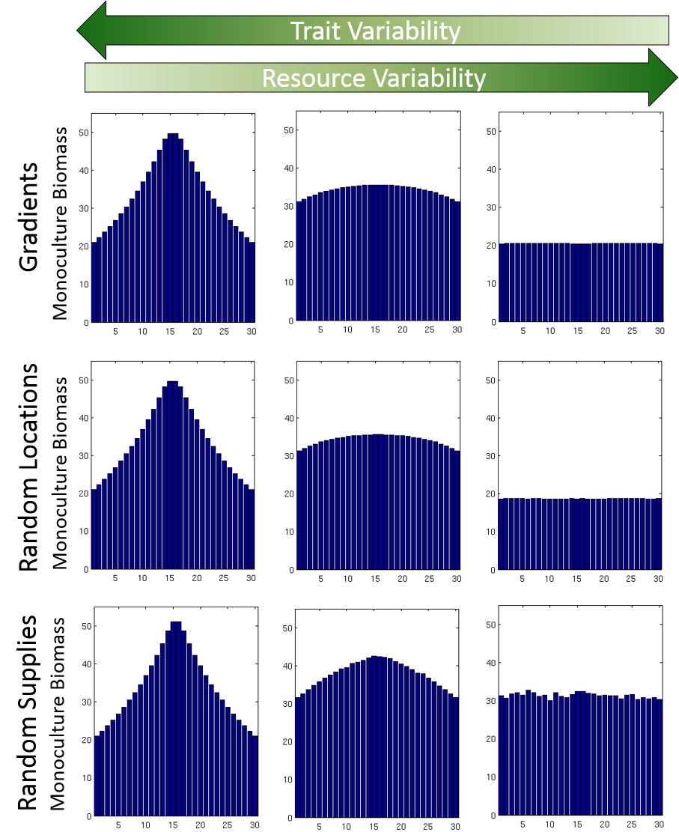

Fig. S3: Monoculture biomass for each species in the 30 species pool under different combinations of trait and resource variability (columns) as well as level of heterogeneity in spatial resource distribution (rows). Presented biomass yields correspond to the following combinations of trait and resource variability: left column: ΔS = 5 (low) and ΔR*=9 (high), middle column: ΔS = 20 (intermediate) and ΔR*=5 (intermediate), right column: ΔS = 39 (high) and ΔR*=1 (low).

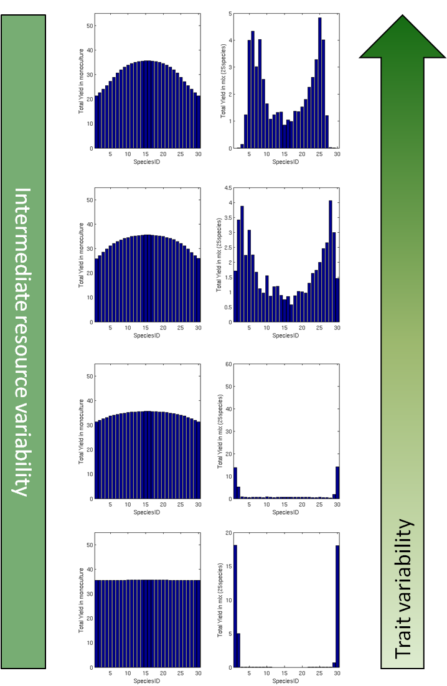

Fig. S4: Biomass production of all species in the 30 species pool in monoculture (left column) and in 25-species mixtures (right column) at a constant level of intermediate resource variability, but differing levels of trait variability. Spatial resource distribution here: Random locations.



Fig. S5: The net biomass increase, complementarity and selection effects obtained for different combinations of trait ($ΔR^{*}$) and resource ($ΔS$) variability for mixtures of 25 species without dispersal. Line colors indicate the scenario of resource supply distribution (Gradients – blue, Random locations – dashed red, Random supplies – green).



Fig. S6: Local (cell-wise) and regional (grid-wise) biodiversity, measured by the inverse Simpson index, for different combinations of trait ($ΔR^{*}$) and resource ($ΔS$) variability, calculated for mixtures of 25 species without dispersal. Line colors indicate the three scenarios of resource supply distribution (Gradients – blue, Random locations – dashed red, Random supplies – green).



Fig. S7: Influence of trait and environmental variability on biodiversity-productivity relationships, calculated for mixtures of 25 species without dispersal. (a) Net diversity effect, (b) complementarity effect, (c) selection effect, (d) normalized biomass, (e) average monoculture biomass, (f) average mixture biomass, (g) functional diversity (Rao’s entropy), (h) regional effective species number, (i) local effective species number. Results are shown for the Gradients scenario.



Fig. S8: Robustness test with respect to model characteristics. Although some components of the model are changed the results show similar patterns to Fig. 5 and Fig. S5. Model modifications: First, boundary conditions were changed from zero flux boundaries to periodic boundary conditions. Second, for each combination of $ΔS$ and $ΔR^{*}$, the maximal growth rates are random numbers uniformly distributed in the interval [1, 2] as opposed to $g_{max}=1$ for all species. Third, the grid size is 50x20, and the initial pool contains 40 species (in the main text, the grid size is 20x20 and the initial pool contains 30 species). The $R^{*}$ values are located on the same trade-off line, and the half-saturation constants are calculated according to Eq. (5) for every $g_{max,i}$.



Fig. S9: Robustness test with respect to model characteristics. Regional and local biodiversity for different combinations of trait and resource variability (compare Fig. 6) for a changed model setup as described in Fig. S8. The obtained curves follow similar patterns as in Fig. 6.